**Lab Experiments:**

Git Installation:

Git is a [free and open source](https://git-scm.com/about/free-and-open-source) distributed version control system designed to handle everything from small to very large projects with speed and efficiency.

Git is [easy to learn](https://git-scm.com/doc) and has a [tiny footprint with lightning fast performance](https://git-scm.com/about/small-and-fast). It outclasses SCM tools like Subversion, CVS, Perforce, and ClearCase with features like [cheap local branching](https://git-scm.com/about/branching-and-merging), convenient [staging areas](https://git-scm.com/about/staging-area), and [multiple workflows](https://git-scm.com/about/distributed).

Steps of Installing git are:

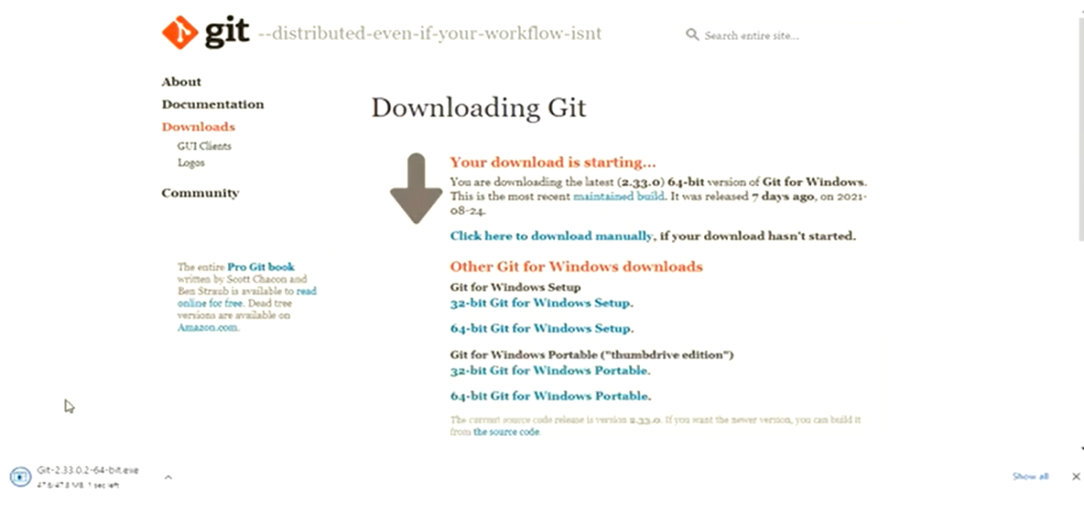

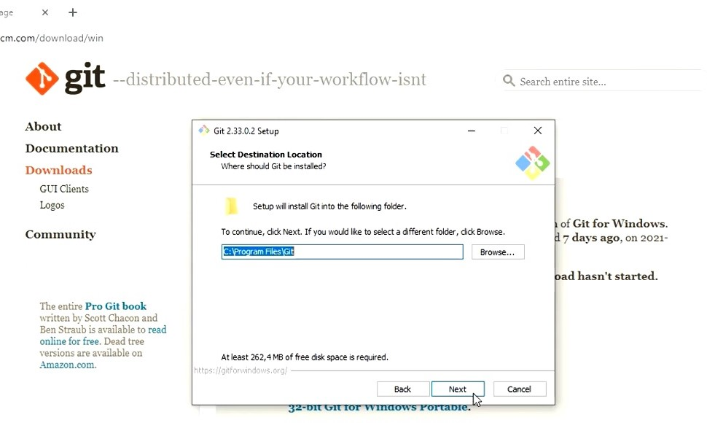

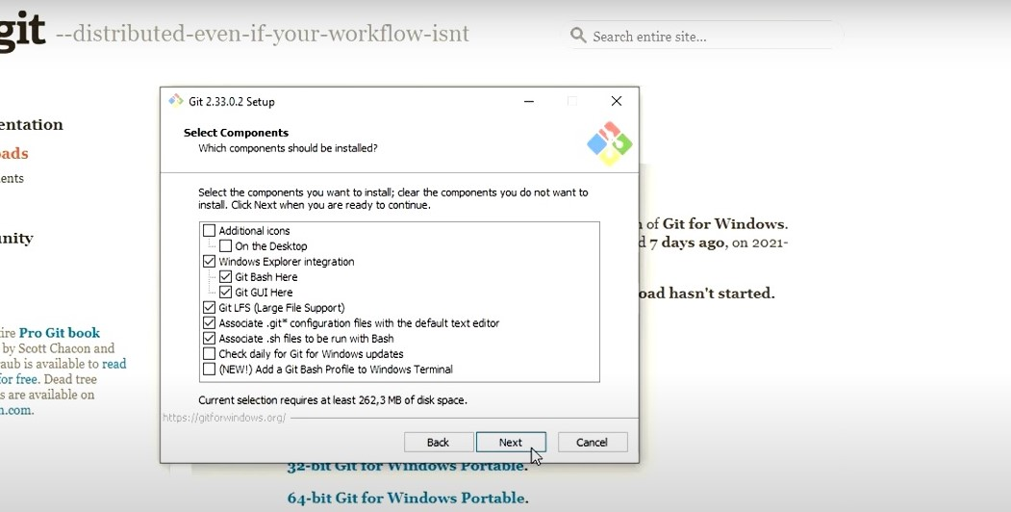

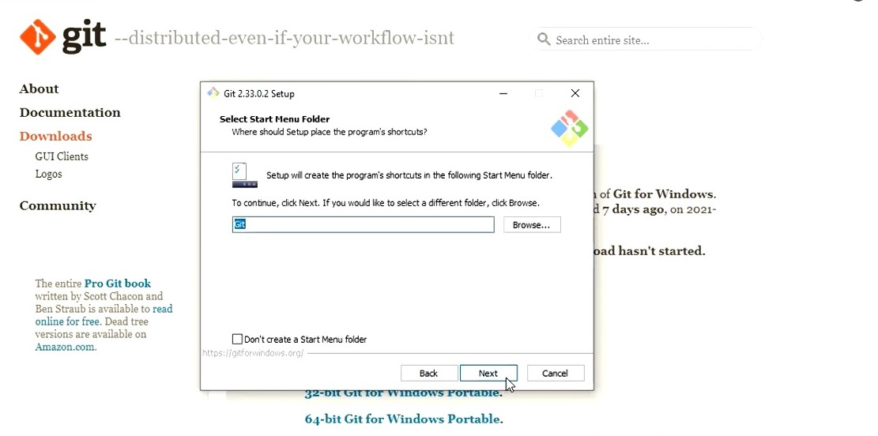

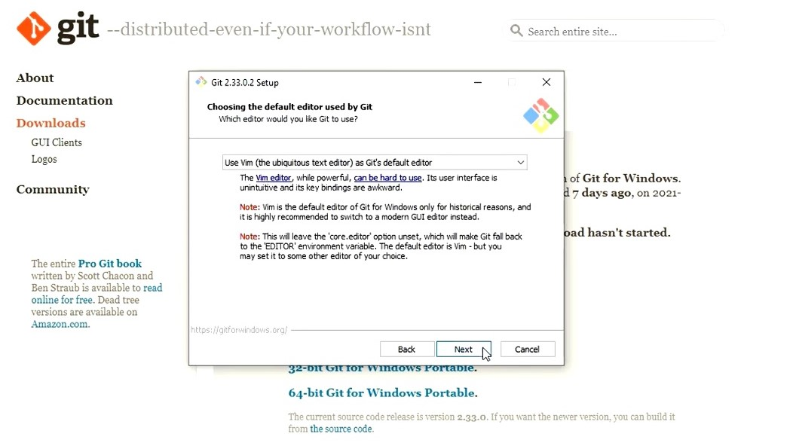

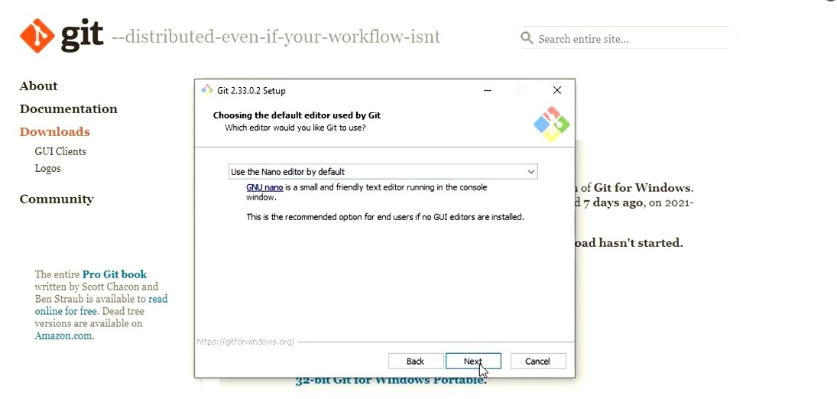

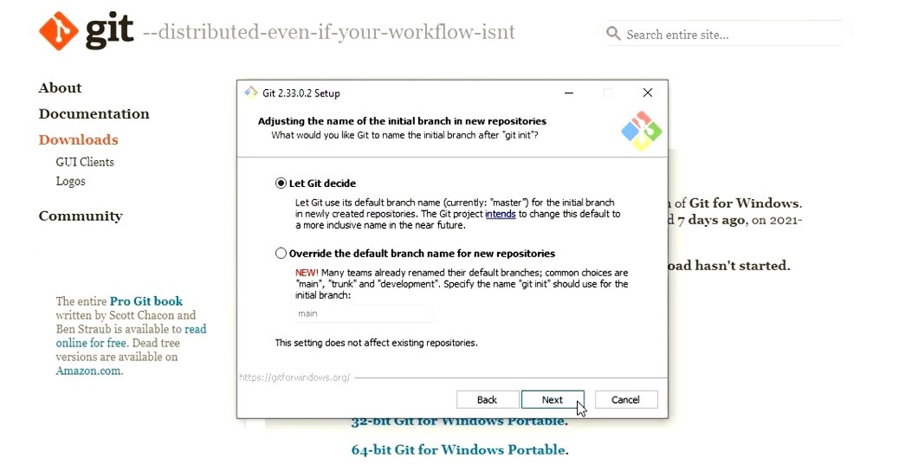

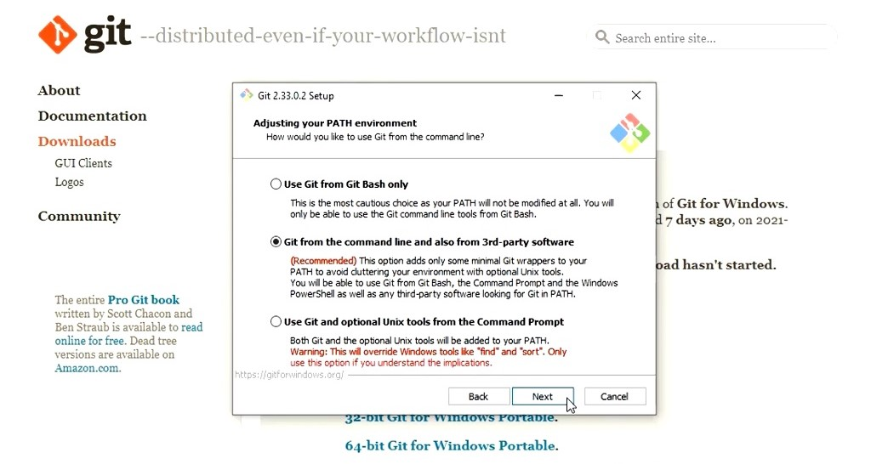

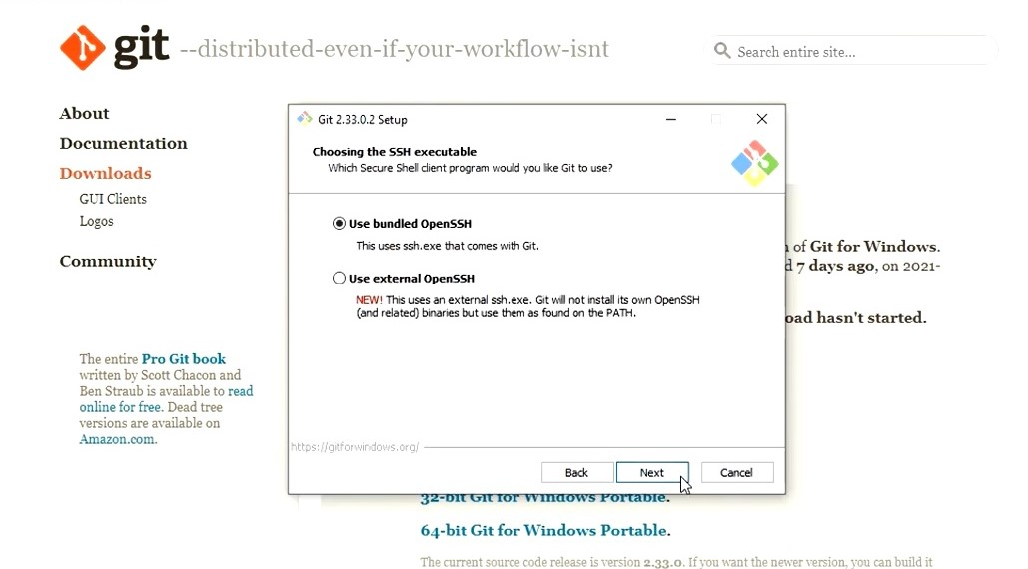

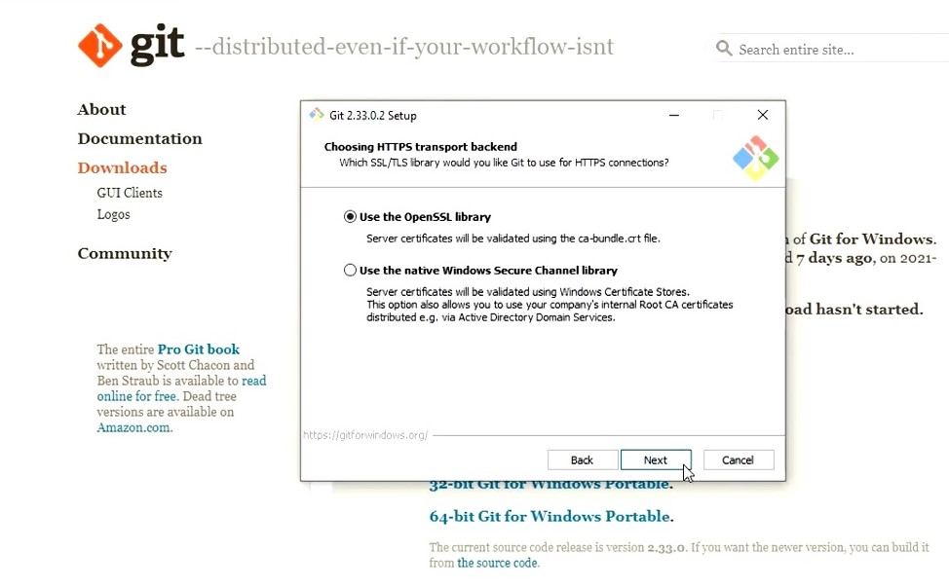

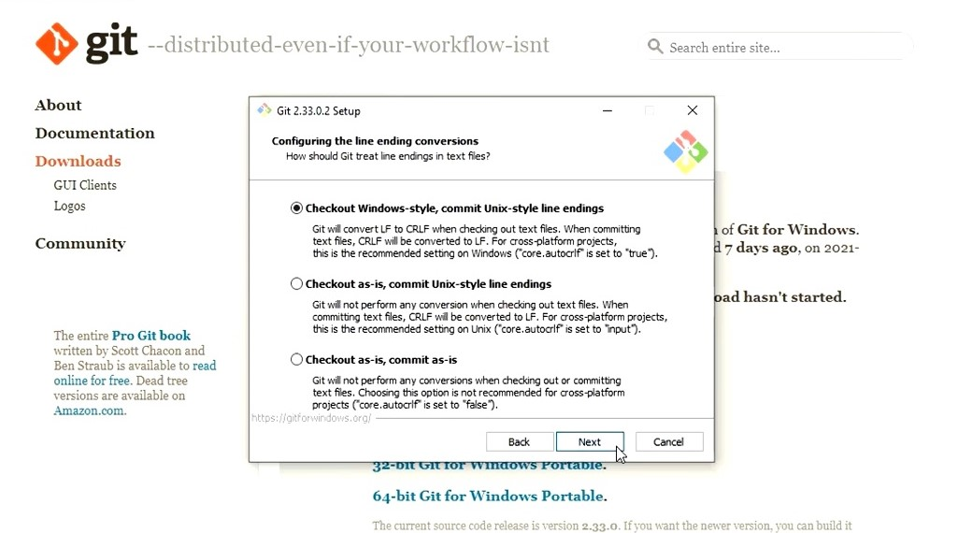

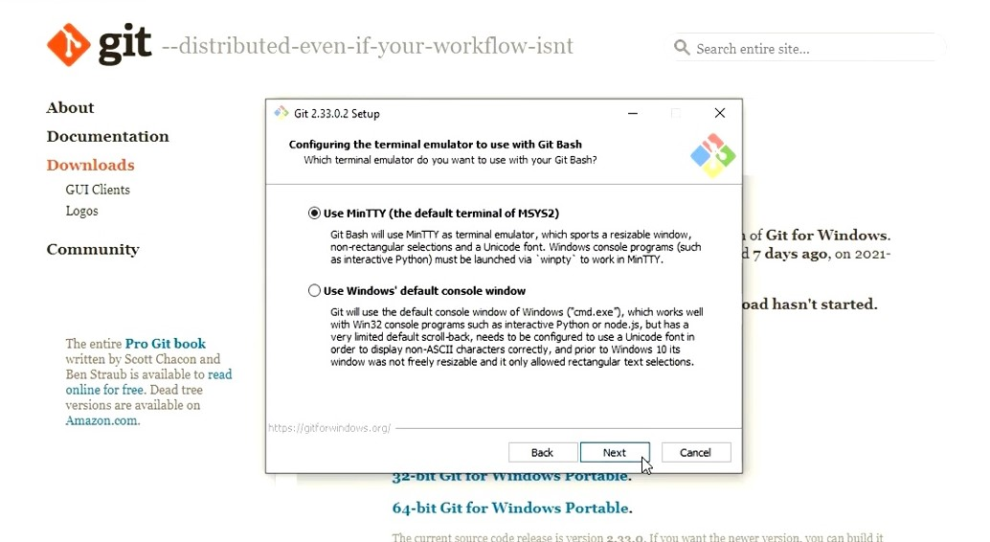

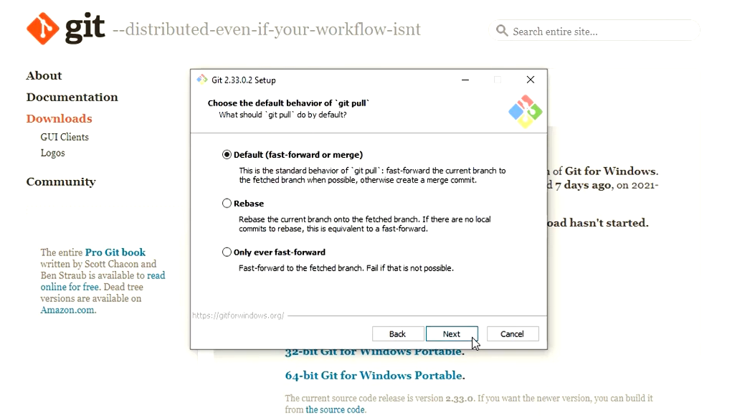

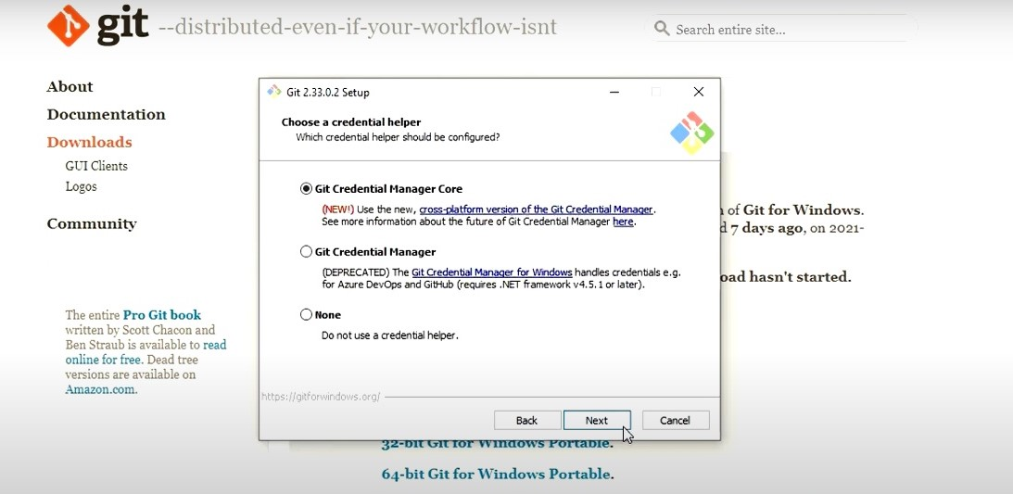

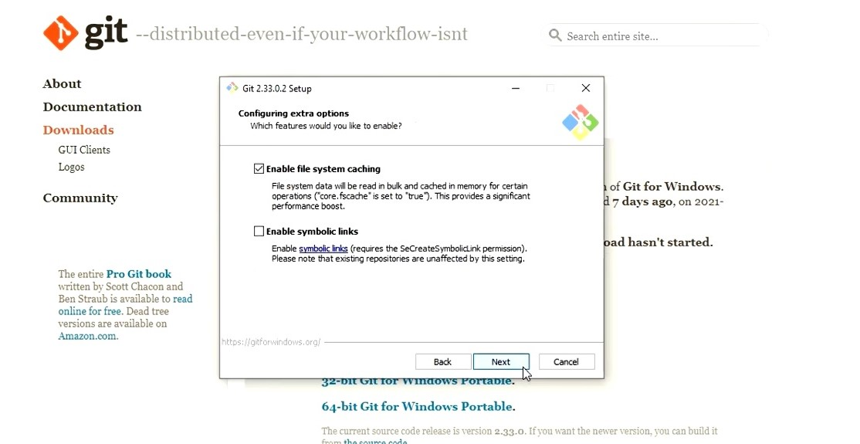

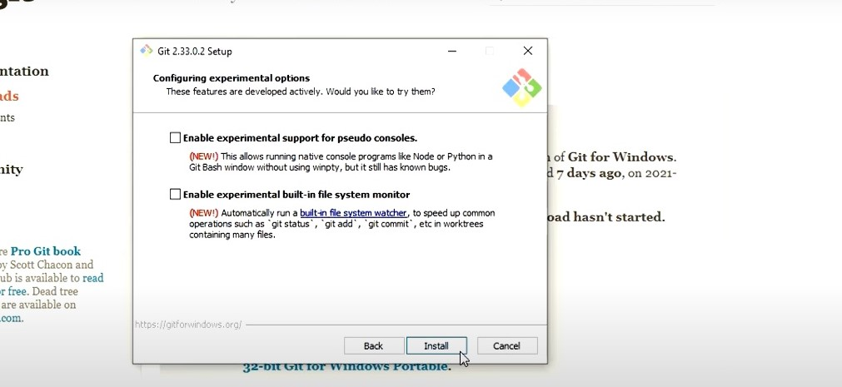

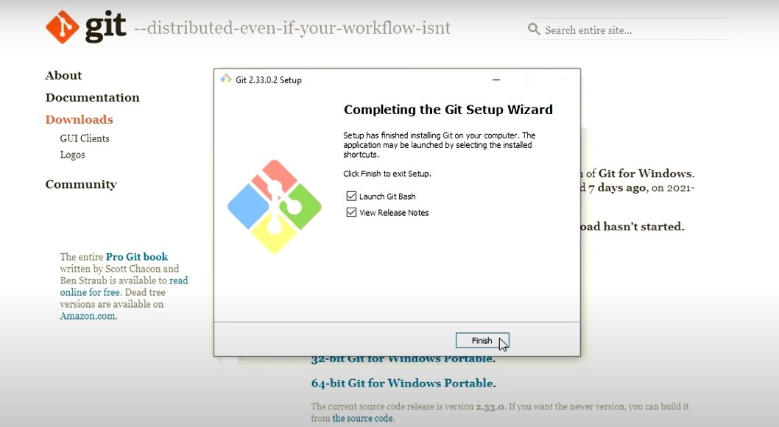

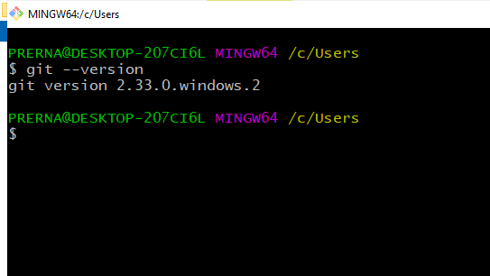

**Bash commands:**

1. ls command - The ls command is used to list files. Ls command on its own lists all files in the current directory except for hidden files.

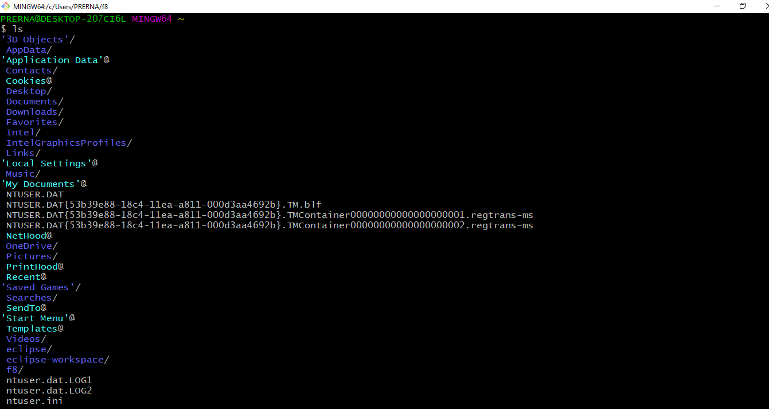

2). ls -ah :- This command is used to list the hidden files.

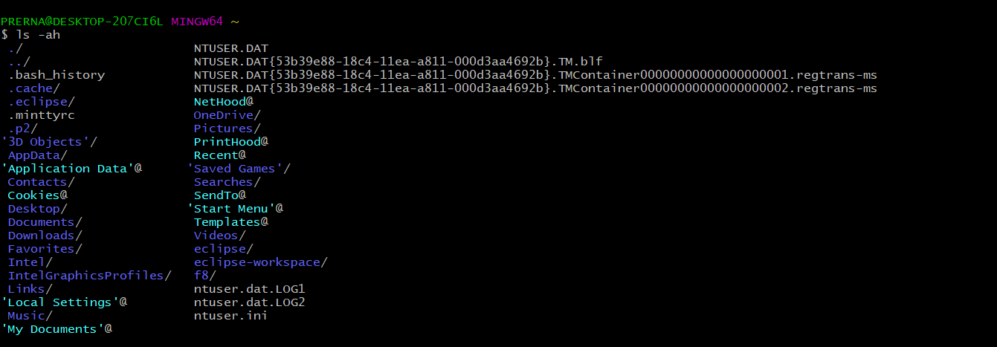

2). mkdir :– The mkdir command which stands for make directory allows you to create a new directory/folder.

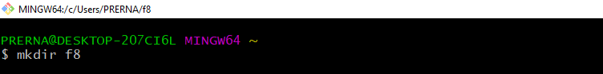

3). pwd :- pwd is used to print the present working directory.

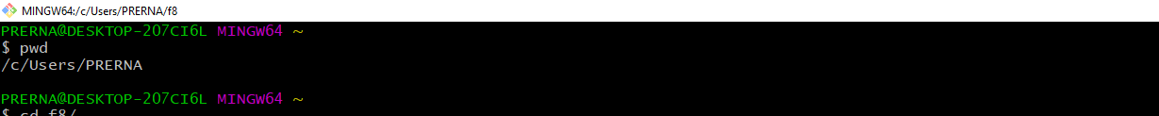

4). cd :– cd command is used to change the current working directory. 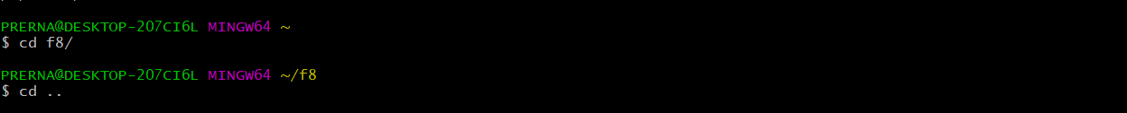

5). vi command - Using vi editor, we can edit an existing file or create a new file from scratch.

cat command -  cat is used to read a file sequentially and print it to the standard output.

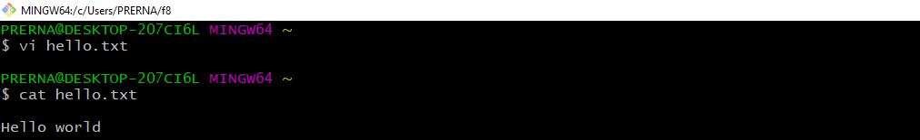

**Git commands:**

1). git init :- git init is one way to start a new project with Git. To start a repository, use either git init or git clone - not both. To initialize a repository, Git creates a hidden directory called . git .

2). git status: - The git status command displays the state of the working directory and the staging area.

3). git add filename: – The git add command adds a change in the working directory to the staging area.

4). Git config :- The git config command is a convenience function that is used to set Git configuration values on a global or local project level.

git config --global user.name “ Name”

git config --global user.email “ Email id”

git config --list

5). git commit -m “ Message” - The git commit command captures a snapshot of the project's currently staged changes.

6).git remote add origin link - This is a command that says "push the commits in the local branch named master to the remote named origin". Once this is executed, all the stuff that you last synchronised with origin will be sent to the remote repository and other people will be able to see them there.

7). git push –u origin master - The git push command is used to upload local repository content to a remote repository. Pushing is how you transfer commits from your local repository to a remote repo. ... Remote branches are configured using the git remote command. Pushing has the potential to overwrite changes, caution should be taken when pushing.

**Demonstration of above commands are shown below:**

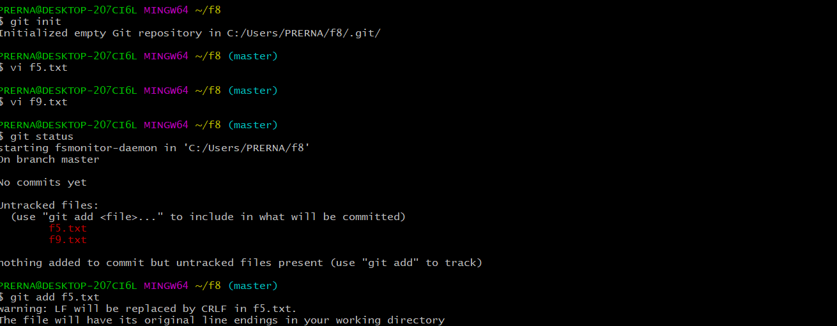

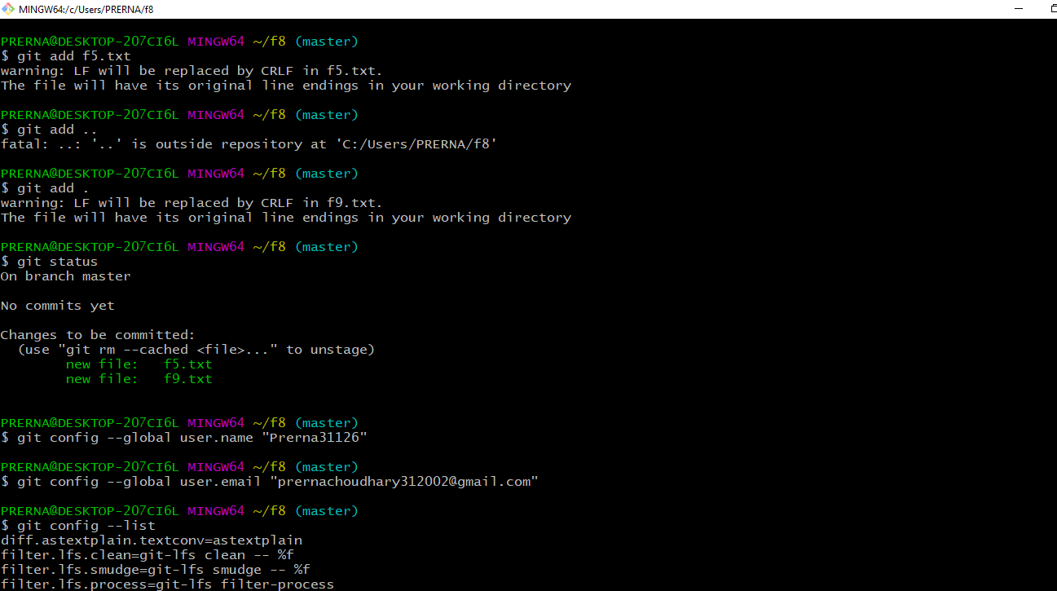

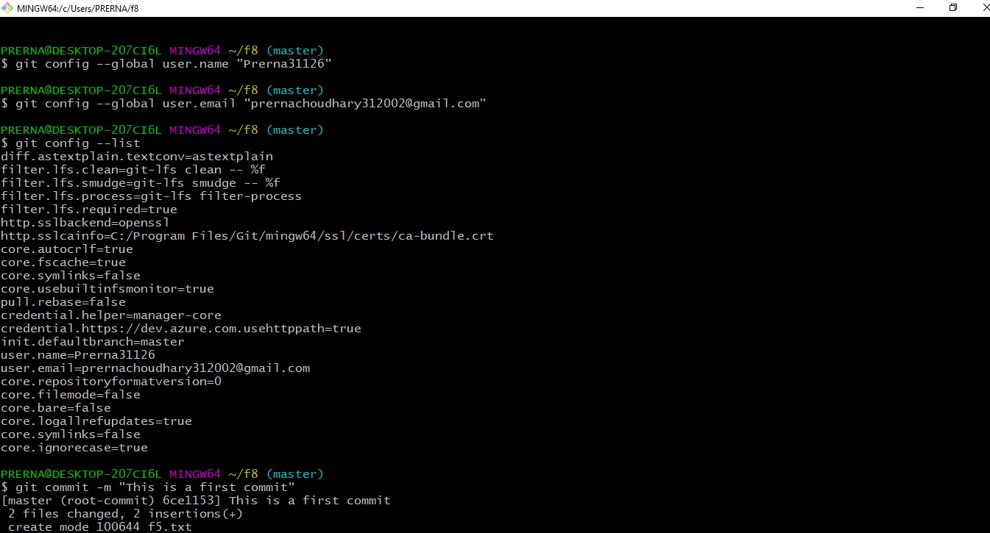

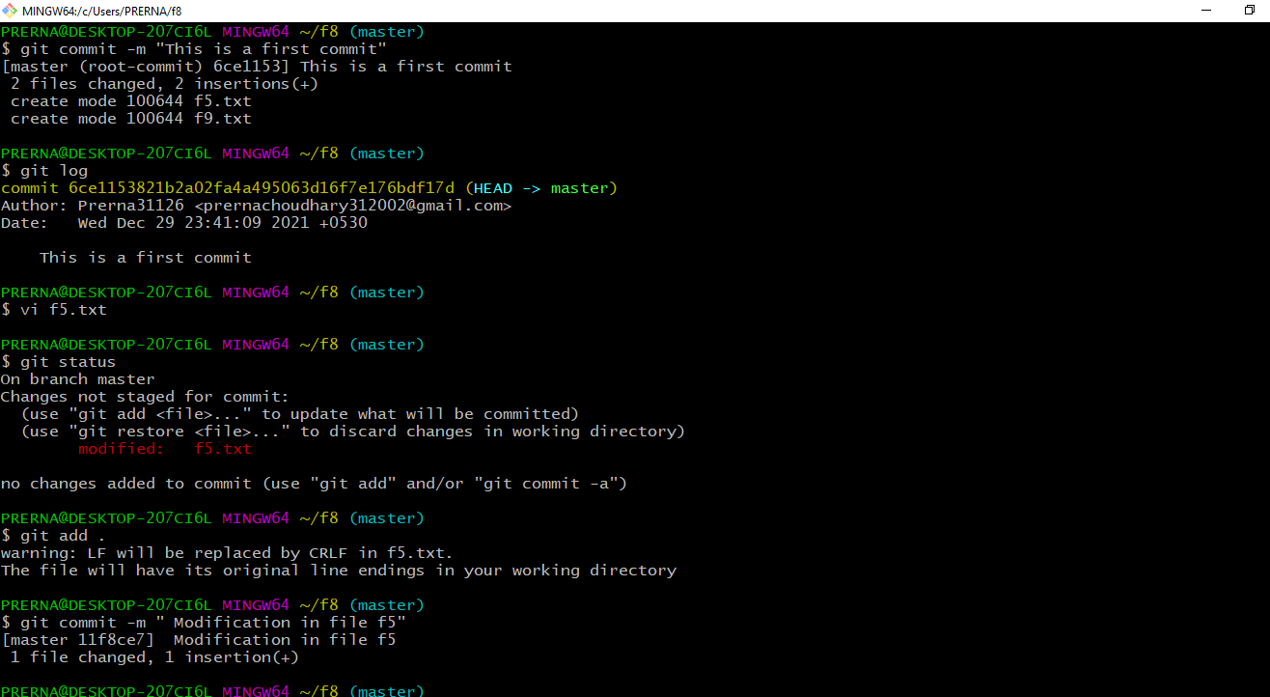

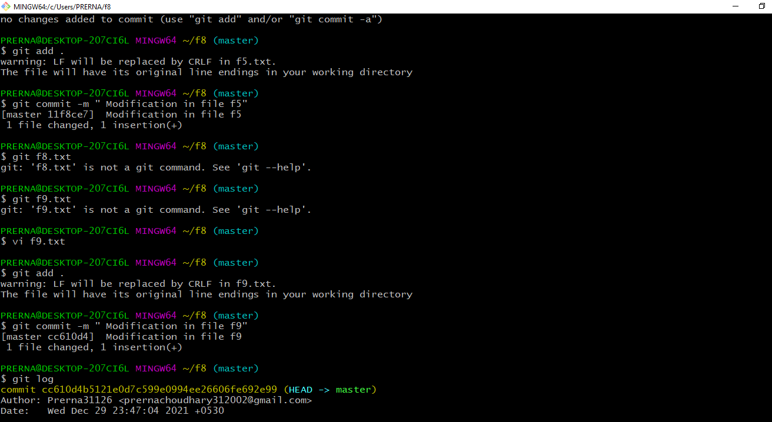

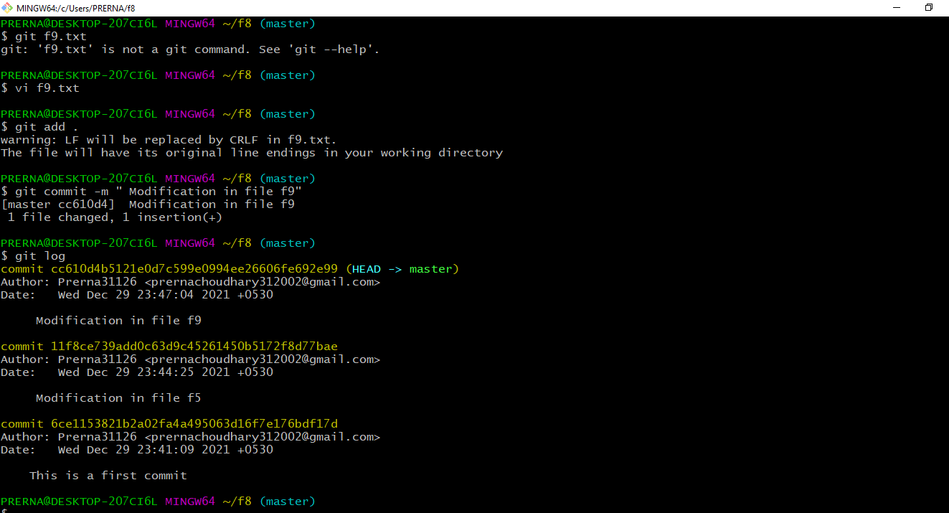

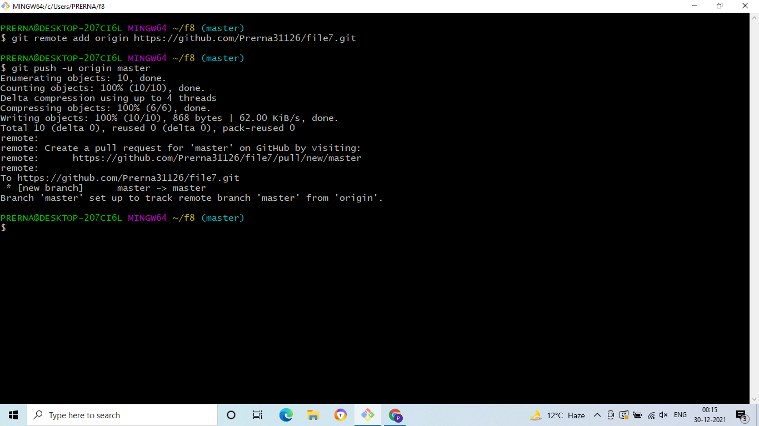

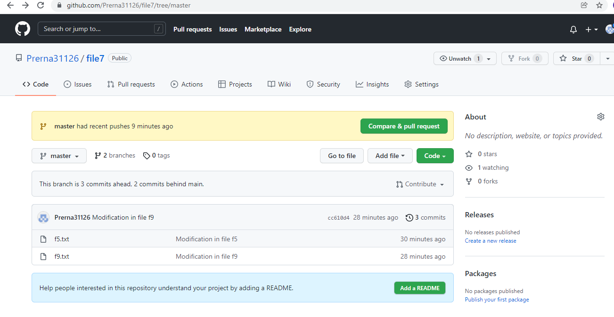

**Git branch:**

1). git branch – This command shown branches in a repository.

2). git branch branchname – This command creates a branch named branchname.

3). git checkout branchname – This command is used to switch a branch.

4). git merge branchname – This command is used to merge the branch.

